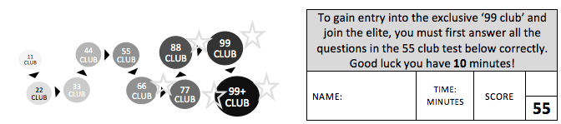

 | 25 + 18 = |  | 19 + 80 = |  | 6 x 4 =
 | 100 – 20 = |  | 56 – 9= |  | 15 + = 100
 | 2 x 9 = |  | 5 x 6 = |  | 64 = 8 x __
 | 5 x __ = 35 |  | 99 - 55 = |  | 7 x 5 =
 | _ x 3 = 21 |  | 35 ÷ 5 = |  | 40 = x 10
 | 2 x 2 = |  | 5 x 1 = |  | 356 + 367 =
 | 4 x 8 = |  | 8 x 9 = |  | 744 - 247 =
 | 7 x 3 = |  | 12 x 8 = |  | 36 ÷ = 9
 | 2 x 0 = |  | 6 x 3 = |  | 10 x = 60
 | 8 x 11 = |  | 4 x 7 = |  | 9 x 10 =
 | 56 + 9 = |  | 5 x 5 = |  | 11 x = 66
 | 110 ÷ 10 = |  | 7 x 8 = |  | 10 x 0 =
 | 67 – 10 = |  | 5 x 5 = |  | 8 x 1 =
 | 87- 20 = |  | ½ of 12 = |  | 2 x 7 =
 | ____ x 3 = 27 |  | 4 x 4 = |  | 4 x 0 =
 | 3 x 8 = |  | 9 x 8 = |  | 9 = 3 x ___
 | 12 x 5 = |  | 5 x 8 = |  | 7 x 4 =
 | 6 x 3 = |  | 3 x 3 = |  | 12 ÷ ___ = 4
 | 20 ÷ __ = 5

