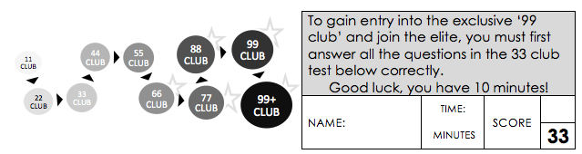
\

10

 | 20 + 30 = |  | 10 x 6 = |  | 86 + 10 =
 | 3 x 5 = |  | = 7 + 13 |  | 4 x 2 =
 | 12 x 2 = |  | ½ of 8 = |  | 15 ÷ 5 =
 | 10 x 5 = |  | 12 ÷ 2 = |  | _____ = 10 x 8
 | 10 x 0 = |  | = 7 + 8 |  | 12 x 10 =
 | 8 x 2 = |  | 20 – 17 = |  | 5 x 5 =
 | 10 ÷ 5 = |  | ½ of 12 = |  | 16 - = 8
 | 25 - 9 = |  | 100 - 50 = |  | 12 ÷ = 6
 | 15 + 5 = |  | 67 - 10 = |  | 4 x 5 =
 | 20 ÷ 10 = |  | 5 x 6 = |  | 2 x 7 =
 | 49 - 10 = |  | 10 x 10 = |  | 20 - ___ = 13

