1 | 11 |  | + 2 + 3 =
2 | 8 | - 4 =
3 | 4 | + 6 |  | + 9 =
4 | 7 | + 3 |  | =
5 | 17 |  | – 1 =
6 | 5 | + 4 |  | =
7 | 15 |  | - 5 =
8 | 6 | + 14 =
9 | 12 |  | – 6 =
10 | 11 |  | + 5 =
11 | 14 |  | – 2 =
 |  | 12 |  |  | 5 |  |  | + 5 =
 |  | 13 |  |  | 11 – 6 =
 | 14 |  |  | 9 |  |  | + 11 =
 |  | 15 |  |  | 13 – 6 =
 |  | 16 |  |  | 8 |  |  | + 9 =
 |  | 17 |  |  | 6 |  |  | + 7 =
 | 18 |  |  | 5 |  |  | + 15 =
19 |  |  | 8 |  |  | – 8 =
 | 20 |  |  | 9 |  |  | – 7 =
 | 21 |  |  | 0 |  |  | + 17 =
 | 22 |  |  | 17 - 10 =
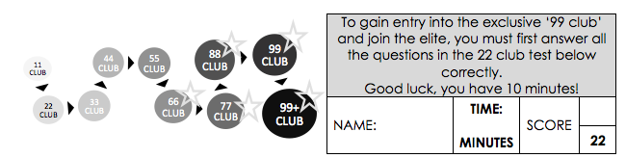
10

