The Boy Who Grew Dragons | 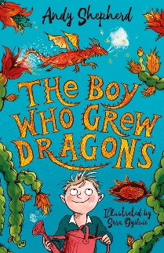
Activity 4



