RECEPTION CLASSES TOPIC MENU: SUMMER TERM 2
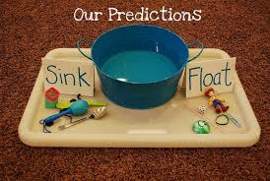  UW Sinking and floating investigation  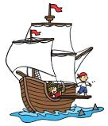  Gather some items from around the house. Which ones do you think will float? Which ones do you think will sink? Were you surprised by anything you observed? You could do this experiment in the bath or in the paddling pool!  You could even pretend the objects are pirates walking the plank! | EAD: Draw a skull and cross bones and fix it to a pirate hat and /or flag. Make and decorate a telescope.  Decorate a treasure box. Fill it with treasures you have found on a trip to the beach or on a walk outside.  Make a seaside collage picture. You could thicken paint with sand and mix colours to paint the sea and sky. When it is dry add shells, stones and pictures of sea creatures to create a collage.  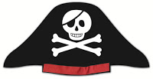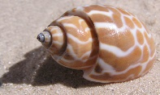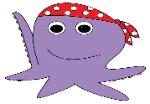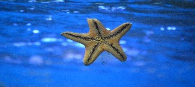 |  | 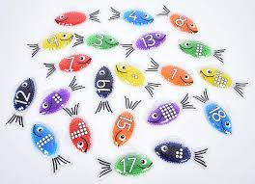  Maths ~ Numbers to 20  Can you; - accurately count at least 20 objects?  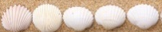  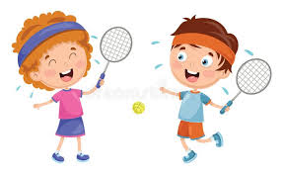  Play tennis (take in turns) counting – pretend to bat a number back to your partner. You can count forwards or backwards to and from 20 in 1s and 2s.  19  202  Use pebbles on 10 frames to make teen numbers and write the number sentence underneath.  Draw a picture to show how you can share 20 sailors between 2, 3,4, 5 boats? What did you find out? 
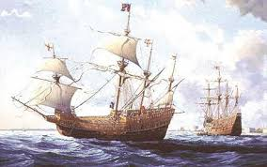  UW:  Investigate the story and treasure of the Mary Rose. the Mary Rose wasn’t a Cornish ship but she was an important one. See if you can find out what was found on the Mary Rose. See if you can find out why she sank. | Maths – Space, Shape Measure Listen to Tiddler the Storytelling Fish https://www.youtube.com/watch?v=pBRT5vsfE3U  Can you see all the clocks in the story? Can you draw the time that you get up in the morning, have lunch and go to bed? | 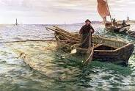  Cornish Treasures | Stories and texts to support this topic:  Who Sank the Boat by Pamela Allen  Tiddler the Storytelling Fish by Julia Donaldson and Axel Scheffler  The Cornish Cats Who Went to Sea by Michelle Cartlidge.  Seal Surfer by Michael Foreman
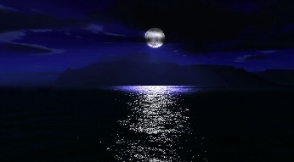  Music:  Listen to Beethoven’s Moonlight Sonata with pictures of the moonlight over the water. Paint a picture of the moonlight over the sea.  https://www.youtube.com/results?search_query=moonlight+sonata | 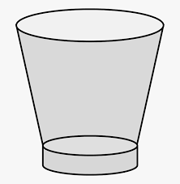    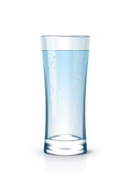  Maths – Space, Shape Measure  Capacity investigation – Being a sailor is thirsty work – if you were a sailor which glass/beaker would you choose to quench your thirst? Gather a variety of different shape glasses or cups, a bowl of water and a small vessel for measuring. What do you think? Why do you think that? What did you find out? How do you know?  Cornish Cream Tea: Follow a recipe and weigh out the ingredients to make scones. Prepare a Cornish Cream Tea, making sure you put the cream and jam on in the correct order! |  | Literacy: Learn the pirate song: ‘When I was one I had some fun.’ Write some new rhyming verses for numbers over five.  Research the lives of some famous pirates. Make a ‘Wanted’ poster to catch one of the scariest!  Hide some treasure in your garden. Write/draw some clues for other family members to find it.  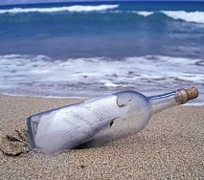  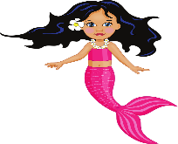  Write a message in a bottle to a creature or mermaid who lives under the sea.

