Garden Adventure  On your walk or in your garden, look for snails.  Ask a range of questions to develop their vocabulary.  What do snails look like?  What do you think snails eats?  How do you think snails travel?  Take pictures | Ocean Tray  Go for a walk, ask your child to search for small stones and rocks. Using a foil tray or plastic container create an Ocean Scene.  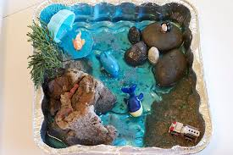 | Painting 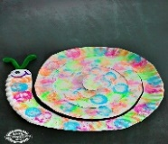  Draw a snail shape on to a paper plate.  Use a peg to hold a cotton ball. Gently dip your cotton ball into the paint then dab on to your plate to create a snail.
Phonic Activity  Use a brush and water to write the letter ‘S’ on the ground. Remind your child to say ‘ssss’ as they write.  ’Up we go, - slither down the snake.’ s  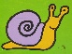  Can your child say and draw any objects that starts with the sound ‘sssss’?  Can your child spot or collect things that begin with ‘s’? | Nursery ~ At Home ~April/May 2020 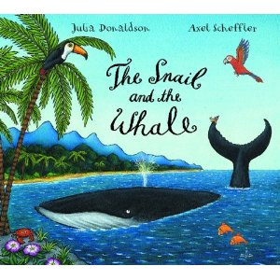 | Maths  Ask your child to draw 5 snails. Carefully cut out each snail. Or use play-dough to make your snails. Can they count each snail accurately?  How many ways can your child separate 5 snails into 2 sets?  Can your child explain how they have done this?  (There are 2 there and 3 here)  Remind them that we always start with 5 snails.  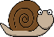  ‘HAVE A GO’
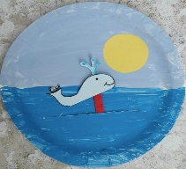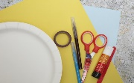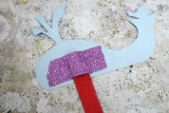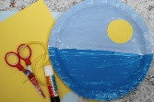
Have a go at creating a ‘Snail and the Whale’ movable paper plate.

