Awe and Wonder

Clean Pennies
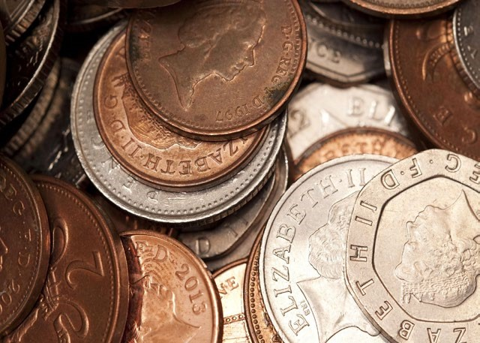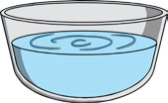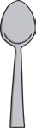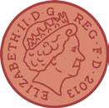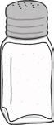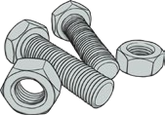
You will need:
Method:
1.
Pour the white vinegar into the bowl.
2.
Add the salt and stir, then add the
pennies.
3.
Count to 10.
4.
Take the pennies out using the spoon.
What has happened?
5.
Rinse the pennies in plain water, what
has happened now?
Spoon
Salt
Bowl of
plain water
Bowl or
shallow tray
made of glass
A few non-
shiny pennies
Whi
t
e vinegar
Nuts and
bolts
- Put some nuts and bolts into the white vinegar and salt, wait for a few moments. What has happened?

- Why do you think the nuts and bolts have gone copper in colour? Where has the copper colour come from?
The Science Bit
Vinegar is an acid, and the acid in the vinegar reacts with the salt to remove what is called copper oxide which was making the pennies
dull and not shiny. When the pennies are taken out, the copper that was making the pennies dull is held in the vinegar. If you put metal nuts and bolts in the vinegar, the copper wants to be with metal and so sticks to the nuts and bolts.

