RECEPTION CLASSES MENU OF ACTIVITIES FOR HOME LEARNING: SUMMER TERM 1
Leaf Threading  Pick some large fresh leaves and punch holes in them around the edges. Thread with wool, string or ribbons. | Fun With Fruit  Try some of the fruits from the story of “The Very Hungry Caterpillar”. Which is your favourite? Squash some soft fruit and mix with yoghurt and food colouring to make some edible paint. What sort of picture or design will you create? | Music Using household objects compose a piece of music to go with the story of “The Very Hungry Caterpillar”. Draw pictures to represent the instruments to create a musical score. Make a video of your performance.
Slimy Friends  Collect some snails in your garden or on a walk. Create a habitat for them in a lidded container (being sure to create some air holes!) Fill with leaves and plants and keep moist. Investigate which fruits or vegetables the snails like to eat best.  Use a large circular tray, mat or container and take your snails out for a race. Start them all in the middle of the tray. Which snail reaches the edge first? | 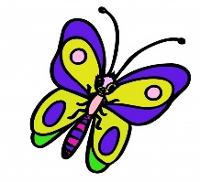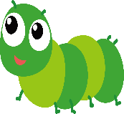  GROWING AND CHANGING  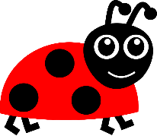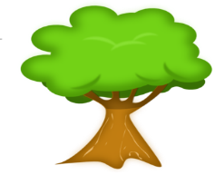 | Cooking  Make some butterfly buns. Bake or buy some plain fairy cakes. Cut a round circular hole out of the top of each cake. Then cut the circle of cake into 2 pieces to make the wings. Fill the hole with butter icing and fix the wings in place.  Make some ladybird biscuits. Cover a rich tea biscuit with red water icing. Use liquorice strips  or laces to make the centre line and the legs. Make symmetrical spots with chocolate chips.
Painting  Cut a butterfly shape out of paper and fold down the middle. Paint a design on one side of the line. Open to reveal your symmetrical pattern!  Make a handprint caterpillar. Paint the palm of your hand green and your 4 fingers brown. Make 4 prints on the paper. Paint your palm red for the head and make finger print eyes, nose, and antennae. | EXPRESSIVE ART AND DESIGN:  Children sing songs, make music and dance, and experiment with ways of changing them. They safely use and explore a variety of tools and techniques, experimenting with colour, design, texture, form and function.  UNDERSTANDING THE WORLD:  Children know about similarities and differences in relation to places, objects and living things. They talk about the features of their own immediate environment and how environments might vary from one another. They make observations of animals and plants and explain why some things occur and talk about changes. | Butterfly Collage  Using sticks, string or wool make the outline of a large butterfly on the ground in the garden. Make a line going across the centre. Using natural materials collected from your garden or when out walking, create a symmetrical collage on the butterfly’s wings.  Alternatively do the same indoors with creative collage materials. Photograph your finished design.

