Nursery – At Home – April 2020
Digging for worms  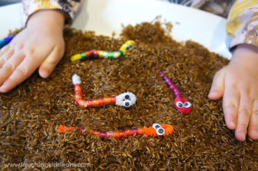  Indoor activity  Thread coloured beads onto a pipe cleaner ensuring there is a loop at one end. Glue on googly eyes (optional). Place the worms onto a bed of brown rice. Use grippers to bury /find them. | 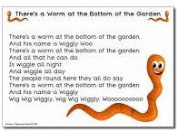 | 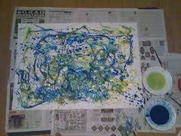  Worm painting  Use pasta and paint to create a colourful worm picture
Worm Discoveries  Go on a worm hunt with your child.  Dig in loose soil, look under rocks around your home.  Next set out two or three worms for your children to observe.  Call their attention to how the worms move.  Have the children experimented to see what the worms like to eat?  Return worms to their natural habitat when your observations are done. | 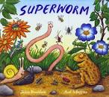 | Create a worm dessert  Easy Dirt Cup Desserts  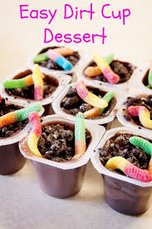  Pack of 4 chocolate desserts  Oreo cookies Gummy worms  Crush the Oreo cookies into small crumbs. Gently mix the crumbs into the chocolate dessert. Place a Gummy worm on the top.
  Playdough worms  Roll a small piece of playdough into your hand to make a worm.  Now can you make a clew of worms? |  |   Worm Jigsaw  Draw a picture of Superworm onto a piece of card. Carefully cut out your picture. Chop your worm into 5 pieces.  Now see if you can put him back together.

