

Early Years Guide to Surviving and Thriving!
Dear Parent and Carers

It has been lovely to see all the activities that your children are busy doing at home and we are so pleased that the children are enjoying the stories.
For the time being the Early Years Team will continue to post stories on Tapestry with little follow up activities as well as the Tapestry web of ideas.

After the Easter weekend we will be posting a half termly menu of topic activities for your child to dip in to as well as weekly writing, handwriting and maths activities for your child to complete as and when possible and to keep the learning ticking over.

We thought it might be a good time now to share some ideas on how you can support your children at home.


Organising your day
You may be wondering how to plan for the weeks ahead and how to organise your days keeping your children busy, engaged and learning and you in one piece!
First of all, remember that any timetabling or plan needs to be based on what suits your family best depending on how many adults are at home and available and the ages of your children as well as the space and resources you have. Please go easy on yourself; use the guidance from school and dip in to the ideas from Tapestry and story time as and when you can. You may find that you will need to tweak, amend or scrap and start again or let things slip as you find out what is working and what is not working for you - and that’s ok!
There are different ways to approach your week (these ideas are based on the guidance for home learning on home.oxfordowl.co.uk ):

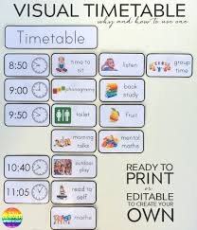
You might like to draw up a timetable showing timings for the different activities that your child or children need to do each day/week. This might be particularly useful if tablets or other devices need to be shared or adults are juggling work and home learning roles.

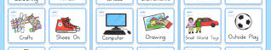
You might prefer to timetable part of the day and leave the rest of the day free for the children to pursue their own interests and for you to get what you need done too. If there are learning opportunities on line like RWI speed sounds lessons and Jo Wicks PE, you could plan those in at the times they are being streamed and then add in other opportunities around those. A partial timetable might look a bit like this. Remember, many of these activities will only take about 10 minutes so there will be plenty of breaks. The timetable should not be set in stone either – flexibility is our middle name in Early Years! What works beautifully one day may not the next for a whole host of reasons. Don’t despair – just do what you can, when you can. Any timetable is just a guide.

  PE with Joe | 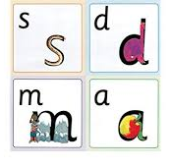  RWI and then snack | 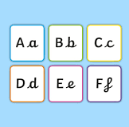Hand-writing with Mrs Sandry |   Outside/free time |   English with Mrs Egleton |   Reading | 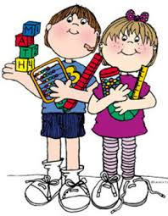Maths with Mrs Finch

 Lunch |  Story from the teachers | Free time… | Learn a song | Play football | Put on a play | Build a den |  Numbots
 |  | Make mud pies | Gardening | Cooking | Bug Hunt | Junk Modelling


You could also use the list approach. Make a list the night before of jobs to do and then in the morning your child chooses the order in which the jobs are done and ticks off each task themselves as it is completed.

Sam’s List

Make my bed

Read to my grown up

Make up a dance

Maths from school

Build a castle

Handwriting from school

Go for a walk/scooter/cycle

English from school

Wash my bike

Lay the table for dinner

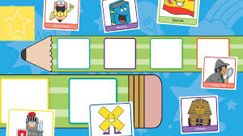
A similar approach would be to use a menu and organiser board. You add the symbols to the non- negotiable spots in your day and the children add the other symbols from the choices on the menu. For example, …

Organiser Board

Morning
Afternoon

Menu


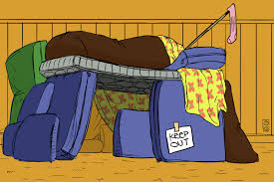



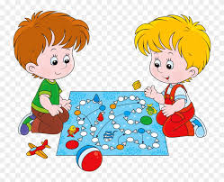

Whichever approach to home learning you decide to take, remember to:


- plan in plenty of extended down time for your child too – snack break – free play, inside or outside if you have a garden


- be prepared to be flexible; if your child is engrossed in a task and wants to continue with it or tired and isn’t going to be able to access it, that’s OK.


- plan in exercise – daily walk out, football, play catch, dance


- be kind to yourself too – there is no one way to do this, everybody’s situation is different. Build in time to do things that you need to do during the day and remember that we are all in the Have a Go Club – just do the best you can!

Behaviour at home

Being at home altogether in these incredibly restricted circumstances are unprecedented and may well be super challenging.

The bottom line is that to feel secure children need consistency and the security of boundaries.

Having some sort of shared plan to organise your day will go some way to provide consistency and routine. It will also be important to establish consistent expectations towards behaviour.

How you decide to do this in your family will be up to you but we just wanted to share a few ideas that might help.

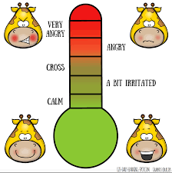
Managing our own feelings!

You have been thrown head long into what can be a rewarding and special time together but also a potentially challenging and stressful situation. There will be times when you will find it difficult to respond to demands and behaviour at home in a measured way. This is when you have to draw on your acting skills (teachers do it all time). Children mirror the way their adults behave and their moods – for example if we (teachers and parents) shout when we are cross, speak sharply or use negative words, so will the children. Be aware of your body language such as facial expression and gestures. If we cannot control how we show our feelings, they will find it hard to do so themselves. As adults it is our job to lead by example so even if inside, we are feeling anxious and stressed, on the outside it is far better for all involved to appear super positive and calm. Easier said than done we know; it is not always easy and it actually does need practise! Teachers practise this themselves. So, to keep everyone on the green part of the emotions thermometer try and do these things as much as you can;
- take a deep breath when needed
- get down to your child’s level to make eye contact
- speak directly to your child
- listen to what they are telling you
- tell them how well they are doing
- tell them how proud you are of them
- be positive and keep it light
- give them your time
- tell them how much you love them


House rules

You might find it helps to establish a set of house rules decided in a democratic way with your children and applicable to everyone in the household.

Our school rules work well in all aspects of our lives ~ We are safe We are ready We are respectful.

At home you might find that you need to tweak these a little and to talk about which each one means. For example

We are safe – playing safely and making sure others around us are safe by not leaving our toys on the floor for example or jumping on the bed.

We are kind – we include our siblings in our games sometimes, we only say things that are going to make people feel happy and comfortable, we help each other.

We are respectful – we listen to each other, we take turns to speak, we follow instructions, we look after our toys. We understand that sometimes we all need a bit of time by ourselves.

Your response then to children not abiding by these rules would be…

‘Are you being safe doing …?’

‘Do you think you are being kind?’

‘Do you think you are being respectful?’

Maybe you could have a reward chart for everyone in the household (including grown-ups) so that your children can see that the rules apply to everyone. They will be the first to tell you if you have contravened one of your house rules and will love it!


Rewards

The best reward your child can get is to hear that you are proud of them. Be specific with the words you use - link them to your house rules. I loved the way you were kind and said that your sister could play with you/you kept everyone safe by tidying away your train set/you followed instructions and washed your hands for tea as soon as I asked you.

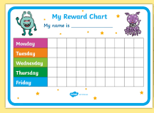
Sticker charts can be super useful too. Try if you can to use a levelled approach – don’t shower your child with stickers or coloured squares – we are in this for the long haul and it is not going to benefit you or the children if your child flies through the chart too quickly. Children love to get it right and usually respond very well to praise. Get support from family or friends – prime them for an influx of celebratory messages and share good behaviour with a grandparent by email or phone message or video call.


When things aren’t going so well

First rule is …choose your battles for your own sake as well as your child’s. You all need this time to be as positive and as light hearted as possible.

Secondly, see if you can work out what is provoking the behaviour. Is your child hungry, tired, anxious or bored? There is always a reason for misbehaviour even though it is not always easy to work it out. Your children are unlikely to be able to tell you so you could be saying things like.

‘You look tired to me I think you might need a break now.’

‘You must be hungry; you haven’t had your snack this morning, let’s get something now.’

It might be that your child is completely absorbed in an activity and cannot move away or even hear you. Giving a 10 minute then 5-minute, 2- minute and 1-minute warnings to a change in activity will usually help here.

Positive reminders of the rules are a timely way to keep get your child back on track.

‘Remember to take turns with the dice.’

‘I’ll show you what I mean.’

If your child cannot stop himself then there are a number of options
- Calmly remove the toy or child from the situation explaining why you are doing so. ‘Come and play with the Lego instead because I can see that the dice game is making you feel cross.’
- Have a short calm down time. Make it brief and explain why your child needs a little time. ‘You need to come and sit by me for a minute because it is not safe or kind to throw the dice at your brother.’
- Finally give your child a chance to make amends. There is no benefit in asking them to say sorry; much better to ask them to change the thing they had got wrong. ‘It would be great if you could come and share the dice fairly now.’ If your child is not willing then you could say, ’Next time then, because you are very good at sharing.’

Then move on – the deed is done; the sanction has been implemented and it is time to start again with a clean slate. Be sure to praise your child frequently when they are getting it right and particularly as soon as possible when they are getting it right after a misdemeanour.


Emotion coaching for when you have a distressed child
It can be incredibly hard dealing with a child who is in melt down but there is a way, based on science, that works! There is always a reason for the behaviour and as the adult it is our job to make the child feel safe so that they can begin to understand their own feelings and build in strategies and language for dealing with the upset. When your young one is having a meltdown, their brain is in a stress response to a situation (perhaps they want the toy a sibling has or they don’t want to go to bed). What you see is a red faced, shouting, crying, distressed child who will not respond to your attempts to placate. Emotion coaching draws on your ability, as an adult, to be calm, to be empathetic and to guide.
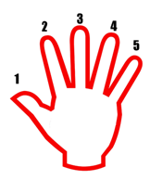
Here is how you can deal with it ……

First of all, and this is important, take a deep breath, gather yourself to bring your stress levels down and wait for the tantrum to subside so that the child can hear your calm voice and see your calm manner. Then you connect with your child.

- Recognise what your child is doing. ‘I can see you have walked away from me because you don’t want to go to bed.’ ‘I can see that you are feeling upset because you are crying and stamping and you pushed your sister away.’

- Empathise. ‘I can understand that; you were enjoying playing with your toy.’ ‘I can understand that you are cross because wanted to play with the animals by yourself.’

- Validate and name the feelings: ‘It’s ok to feel cross/sad when you can’t do something you want to do.’ Or ‘Sometimes we do feel upset.’

- Set limits on behaviour (reason). – ‘It is really important that we all get enough sleep though so that we have enough energy to run and play in the morning. It is time for bed now.’ ‘I can understand that you might not want to share at the moment but it is not ok to push.’

- Problem solve with the child. – ‘Next time when you feel cross you can tell me how you are feeling and we can sort it out together.’ ‘Next time your sister wants something you have you can say – ‘I’ve nearly finished, you can have a turn after me’ or ‘we can play together’ or you can ask me to help me you sort it out.

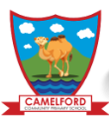
Keeping the learning going ~ post Easter weekend
We appreciate that for most of you this is a brave new world in very restricted and challenging circumstances. Your child will need your support to access the following. Please just do what you can, when you can and ask if you have any questions.

Phonics
Please continue to access the RWI speed sound lessons which will be live streamed on Facebook and YouTube each day at the appropriate level for your child. These can now be linked to the RWI activities available online at home.oxfordowl.co.uk. After watching the live programme there are practise sheets for the particular sounds which have been learnt, as well as e-books to read at the appropriate level and speedy green word videos. There are also lots of helpful videos for parents giving guidance about the overall teaching methods used in the RWI program. Please do not hesitate to ask if you are unsure about the particular set of speed sounds which your child should be working on at present.

Reading
Read a story with your child every day. Look at the front cover and use it as a prompt to ask questions. Who is in the story? Where is the story set? What might happen? Has your child ever been to a place like this? Has something like this happen to them? As you share the story talk about the pictures/ characters and what they might be feeling/ might say. When you have finished the story ask your child whether they enjoyed it and ask them to give reasons why/ why not.
Make sure that you also make a time each day for your child to read to you. If you are running out of suitable books at home there is a free e-book library available on the Oxford Owl site with plenty of books at the appropriate level for your child. home.oxfordowl.co.uk
Writing
We will be uploading some handwriting videos for you to access each week. These will help your child to continue to make progress in forming their letters in the pre-cursive handwriting style which we have begun to learn in the reception classes this year.
We will also be setting creative writing tasks each week for you and your child to work on together. These will usually be linked to a particular story or non-fiction text which we will share with you on Tapestry at the beginning of the week.
Maths
Each day we will be posting a little maths challenge for your child to do at home. It will be based on the White Rose Maths scheme which we dip in to at school. The activities will be linked to a story but can stand alone too and can usually be done in any order. We will endeavour to post the story on Tapestry when we can although this obviously depends on our own access to books! Over the week there will be a mixture of fun number and space, shape or measure activities. We appreciate that you may not have access to some resources so we will sometimes suggest alternative ways of practising the same skill.

Finally,
Dear Parents and Carers,
You are amazing! Do what you can, when you can. The children will catch up with learning they have missed when they are back in school. Your most important job now is keeping your family safe, healthy and happy.
Best wishes from us all,
Mrs Finch, Mrs Egleton and Mrs Sandry

