Accelerated Reader
“Reading is important. If you know how to read then the whole world opens up to you” Barack Obama

Dear parents/carers,
During this time, it is vital that our children continue to read. Reading opens to the doors to so many opportunities and allows them to access all areas of the curriculum.
To support the children’s reading, AR has changed their licensing which means we are able to test at home. Please find all the information about how to access it below.
If the text your child is reading is not on AR, please do not worry. The focus is reading, not testing. When your child is reading, you can ask them questions to support their learning (I will send out resources to help you with this). It does not all have to be done on AR.
If you have any questions, please do not hesitate to contact us. If the class teacher is unable to help, they will be able to contact me for advice.
Keep safe and look after yourselves.
Kind regards,

How do I access Accelerated Reader?
To access AR, you must go on the website:
The website is specific to each school so please check you are using the correct website. The children are all aware of this.
Click on ‘I’m a student’
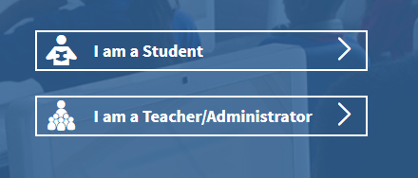
Type in your username and password.
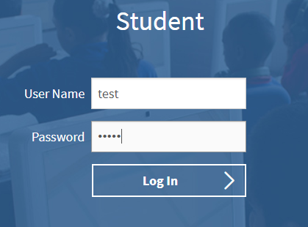

Click on ‘Accelerated Reader’ (the third box).
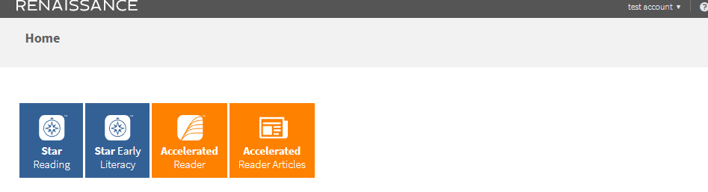

Type in the book details. See ‘How do I know if their book is on AR?’ for how to find a quiz number.
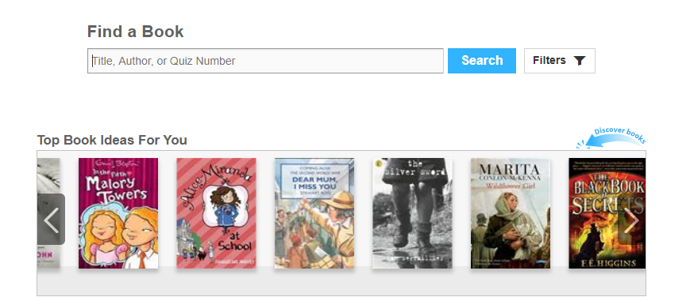

Select the correct book from the list. Be mindful that the picture sometimes looks different to the front cover as some books have different versions of front covers. Click on ‘Take Quiz’.
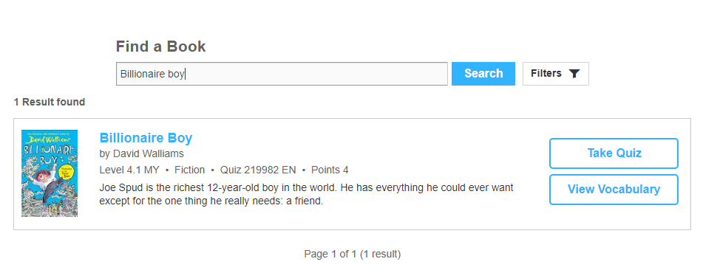
When you click ‘Take Quiz’, it will ask how your child read the book. If they read independently, your child should do the test independently. If they read with someone or if they were read to, you can read the questions to your child but do not help them with the answers. The ‘Start Quiz’ button will appear once you have selected one of the options. On some tests it will ask if you want the recorded voice on or off (the questions are read aloud).
The children are allowed to use the books to retrieve the answers.
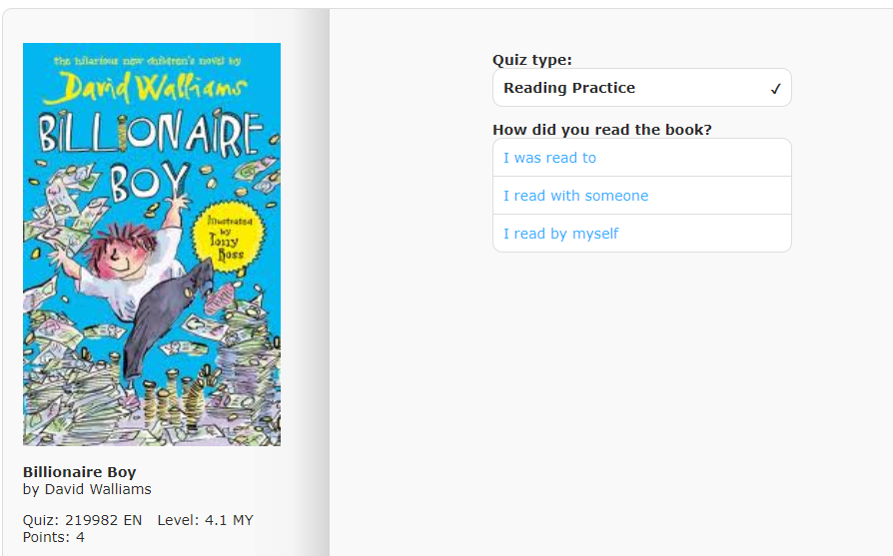
When you finish the test, it will give you your score and how many words you have read.
If it offers a vocabulary test, then your child should do it. Click on ‘Find my next book’ to end. This will take you back to the ‘Find a Book’ page.
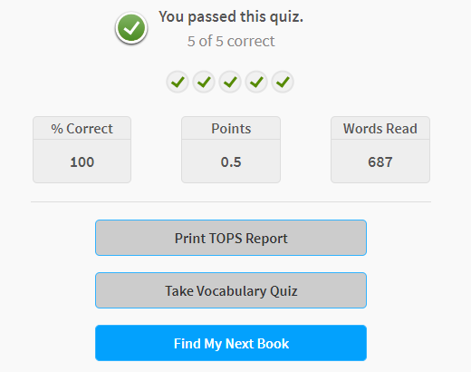
How do I know if the book is on AR?
Visit https://www.arbookfind.co.uk/
It will ask you who you are. It does not make a difference when you click on the different options.
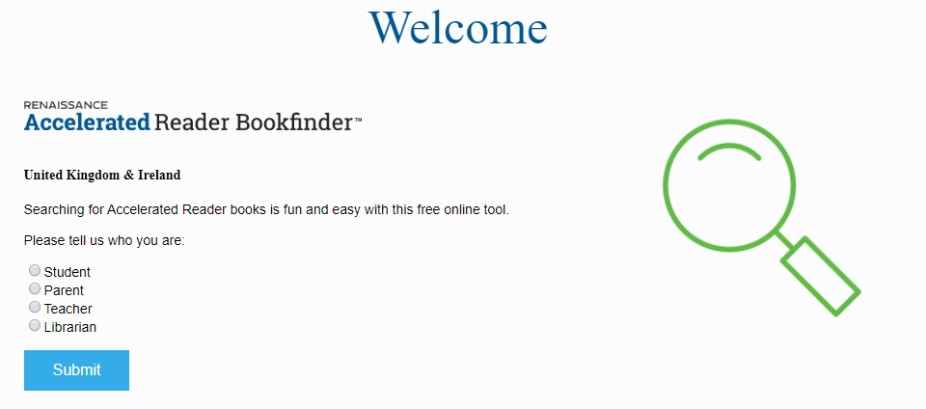
Type in the name of the book. Be mindful that the book covers might not look the same.
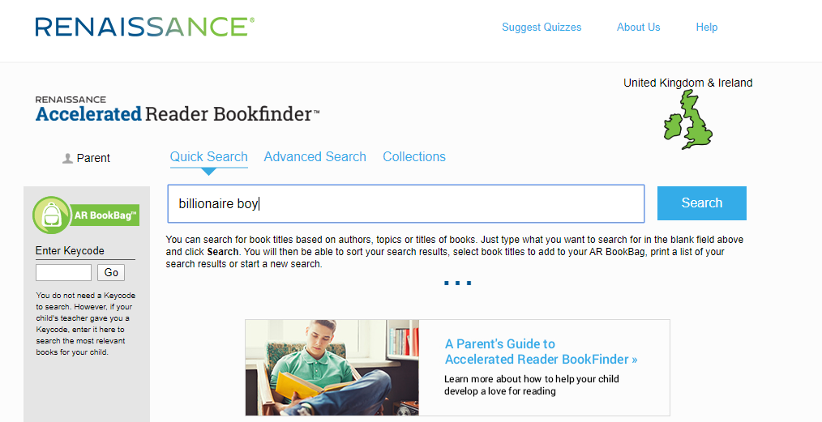

Locate the book in the list. It will show the quiz number under the title and author.
BL = Book level (this is the levels within their ZPD) e.g. your child’s ZPD may be 2.1 – 3.2
IL = Interest level. LY is lower years so lower years and MY is years 5/6.
Do not worry about the interest level unless you are concerned over the content of the book. If the book is not in their ZPD then that’s okay. It is hard to accommodate this without the school library. We just want the children to read!

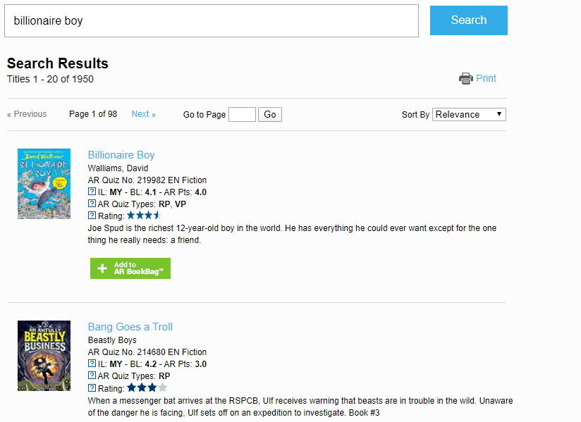
“I do not have access to many books/my child has read all of their books. Where can I locate other books?”
This can be tricky but there may be some books online. It would be worth checking the following sites if they have any books that can be used on AR. If they do not then that is okay. The priority is reading, not testing. We would much rather the children reading so if it does not have a test then please do not worry.
If you find any websites with free books, please share them with us. We will also continue to share anything we find. It may also be worth looking at Amazon Kindle as they do have some free books or Audible free trials. Please make sure you look at all terms and conditions if you do this.
https://worldbook.kitaboo.com/reader/worldbook/index.html?usertoken=Mjk5MzQ6MTpJUjA5MjAxNjoyOmNsaWVudDE2OTc6MTY5NzoyMjE2Mjg4OjE6MTU4NDM4MDExMzA2Mjp1cw%3D%3D&fbclid=IwAR3XepFS0xeb0K58fL-fp8U0N9z1cyVM2I9uB55UtWHlyBQWRGCp5vy7Izs
https://magicblox.com/?fbclid=IwAR0W9oA3LS2scBK73tA6CKQJ3YcnD3gxVN8i1vbhFC-ISvKMUlRkaTBqoW4

If you are a member of the local library, you can also access eBooks through them. https://www.cambridgeshire.gov.uk/residents/libraries-leisure-culture/libraries/library-online Click on eBooks and there will be a link to the eBook platform. I believe you need your library card details to do this.
YOU’LL HAVE TO CHECK THIS

