Maths 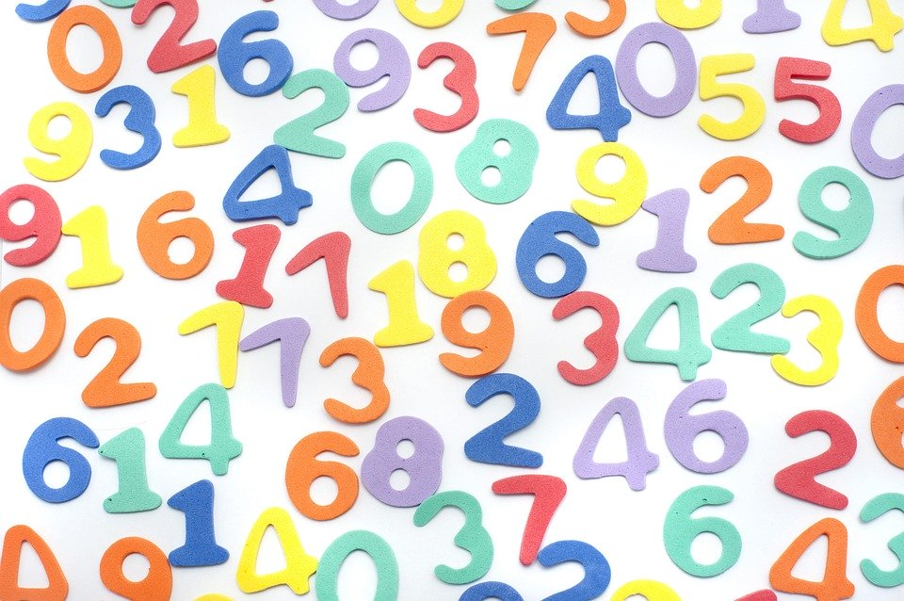
Play My Turn Your Turn counting from 0-20 (or beyond – we got all the way to 100 in class) and 20-0 with an adult or friend.
Player 1 counts ‘123’
Player 2 continues ‘456’
Player 1 ‘789’
Or Player1 ‘20 19’
Player 2 ’18 17’
And so on.

Maths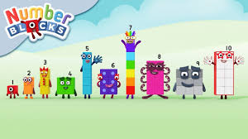
We have been learning to add by counting on and subtract by counting back. This episode of Numberblocks supports this by investigating number bonds within 10.
https://www.bbc.co.uk/iplayer/episode/b0bn5dz7/numberblocks-series-3-five-and-friends

Technology
We have been making goat puppets with moving parts in school. What can you find with visible moving parts? I wonder how it works.
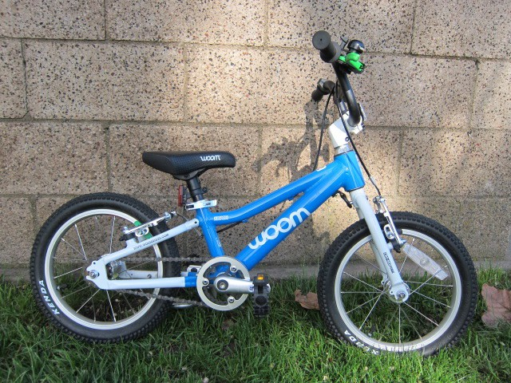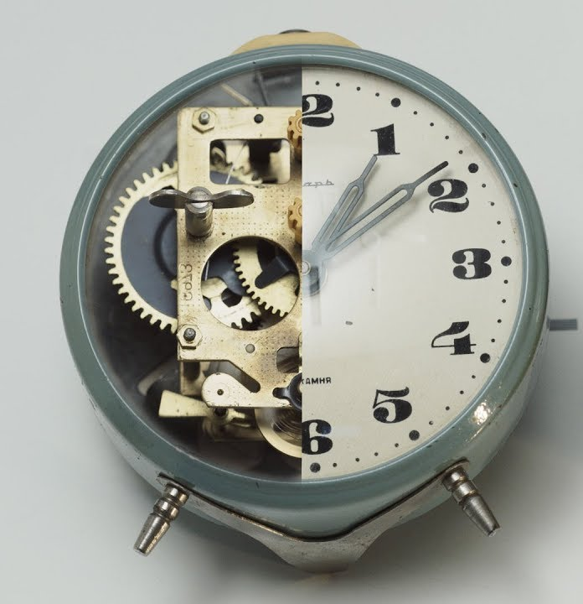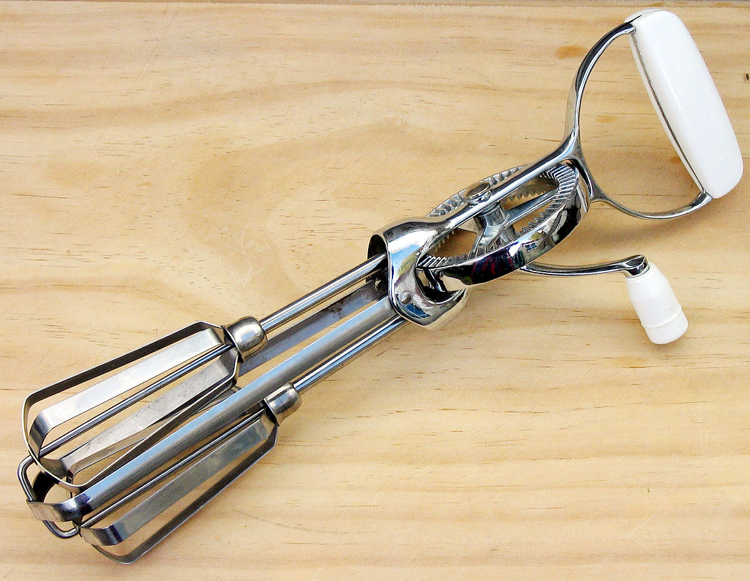

Easter is a Christian celebration in the spring. It is a time to celebrate new life.
Do you celebrate Easter in your family?
Write about your Easter. Write as many sentences as you can. If you would prefer, write about a special time with your family.
Remember;
- to think about what you want to write first, practise saying the sentence
- Use Fred fingers to sound out words, and write the sounds you can hear and know
- Most of all, remember you are in the Have-a-Go Club – you are fearless writers!

What do you know about spring?
Draw and label some pictures showing what you already know.
Remember to use pre-cursive writing!
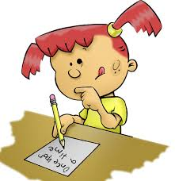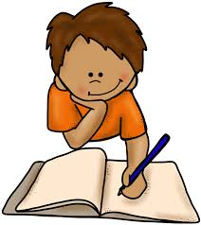

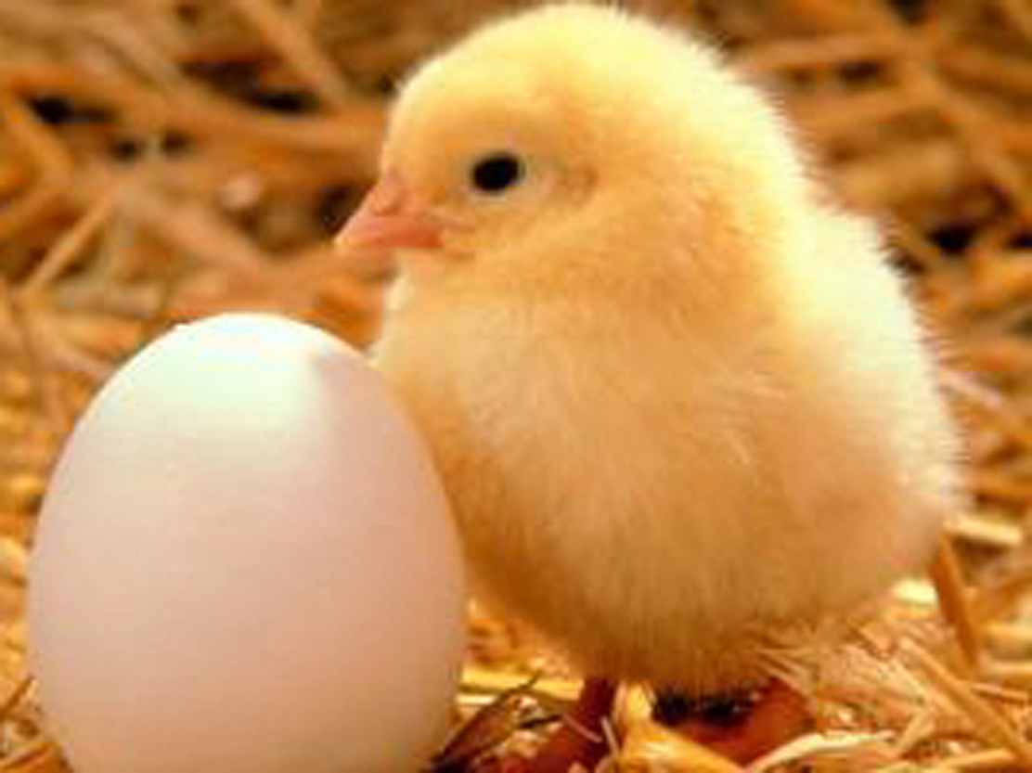Spring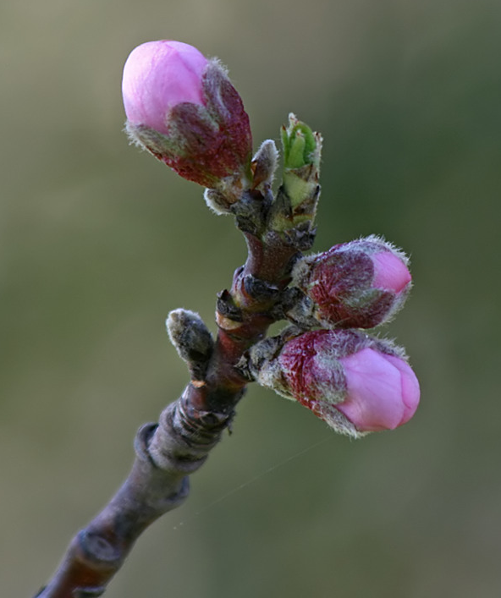
Home Challenges March 2020
If your child would like to have a go at some of these challenges and you can take a photo or video, please upload them on to Tapestry, we would love to see them.
Mrs Finch, Mrs Egleton and Mrs Sandry

